12.11.07

{x^(p)→d^(p)}

$\left\{φ(x\hat{(}p)→(d\hat{(}p))\right\}$

Processing of data

Backpropagation
(X^(p))$→(0\text{.}\text{.}\text{.}\text{.}\text{.}\text{.}\text{.}0)→(0\text{.}\text{.}\text{.}\text{.}\text{.}\text{.}\text{.}\text{.}0)→y\hat{(}p))$
An increase of hidden inputs would make this more powerful.
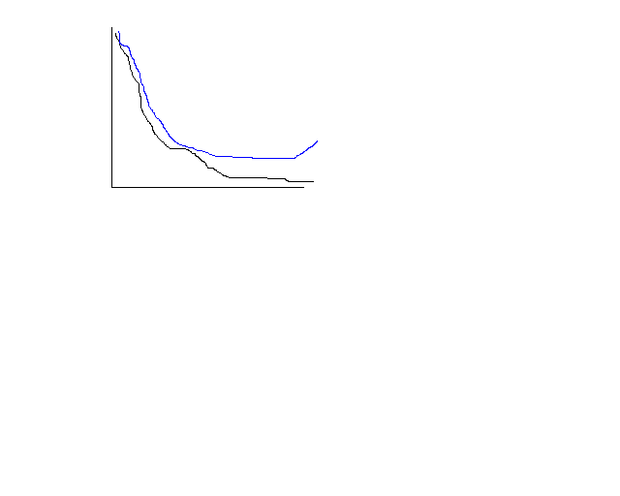
Support vector machines (SVMs)

Advantages
+Not “touchey”,Robust.
+Easy to get pretty good general performance.

Disadvantages
-Field speed low
-hard to tweak

Perception classifier (linear classifier)

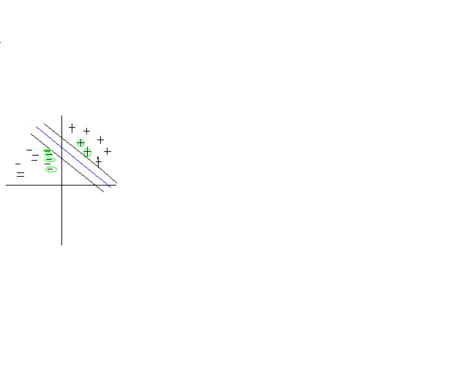
“Margin” E is max,such that all points in dataset , E-Balls around correct side.
-choose line which has max margin.
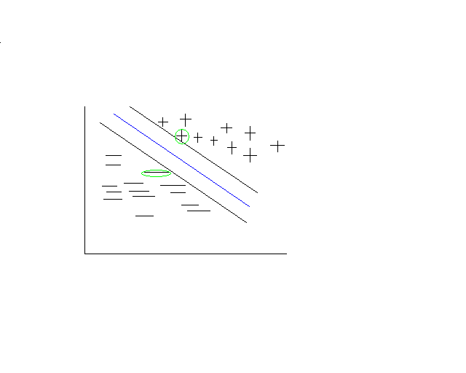1. Efficient algorithm for finding (m.m.h)
2. outliers/noise
3. “Kernel trick”
1$∀p$ x^(p)$w$ >= $φ+E$If d^(p)=+1
2 x^(p)$w$ <= $φ+E$If d^(p)=-1

W’=w/E $φ'=φ\text{'/}E$

Multiplying 1 by d^(p)

D^(p)(x^(p)W’)>=d^(p)$φ$’ + d^(p)
D^(p)(x^(p)W’)<=d^(p)$φ$’ - d^(p)
D^(p)(x^(p)W’-$φ$)>=1

Quadratic Programming (QP)

